**Priority 1**

Salves / Moon Cream /– two sizes 2 oz (1”t x 7.25”w) and 4 oz (1.75”t x 8.75”w)

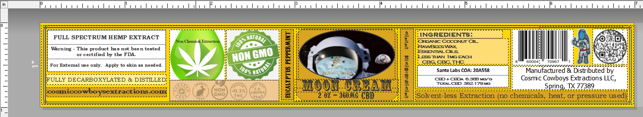

Tincture Bottles / Interstellar Elixirs / - 1.97”t X 3.7”w The pet tincture is called Emotional Support Elixir

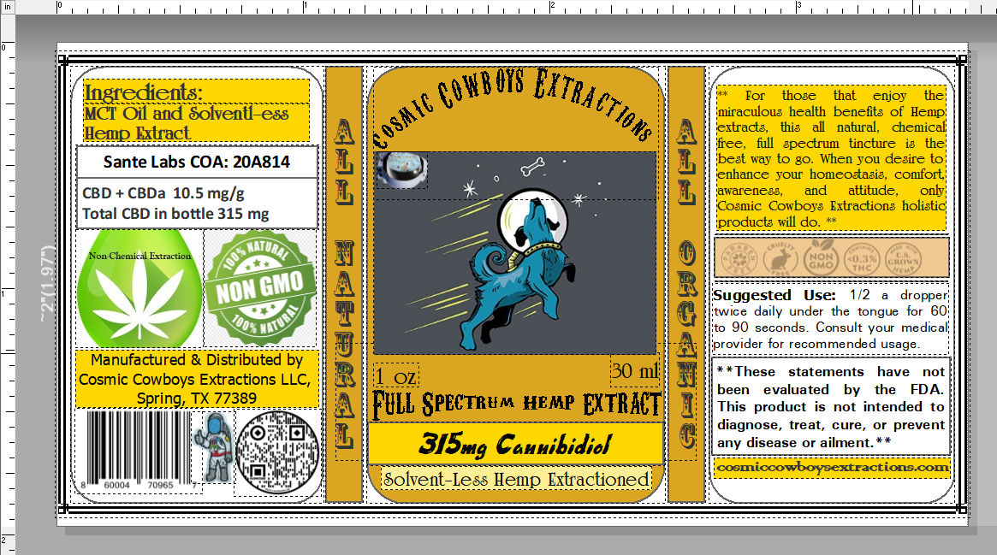

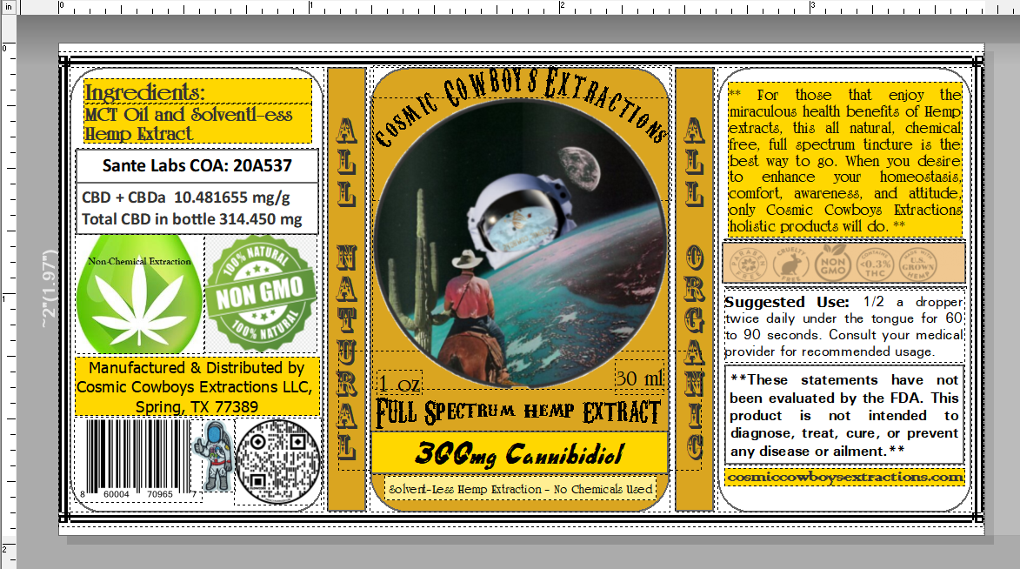

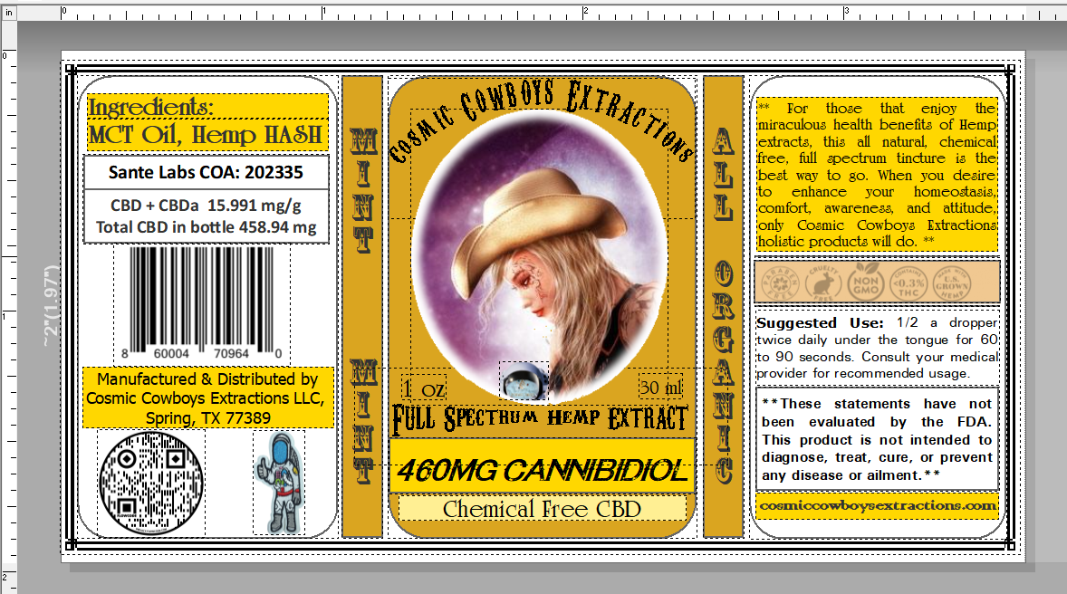

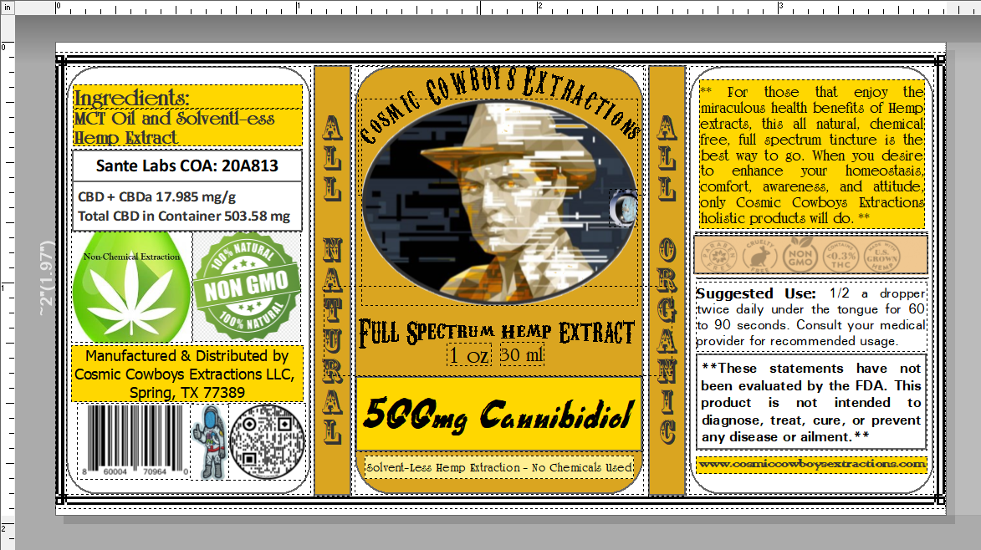

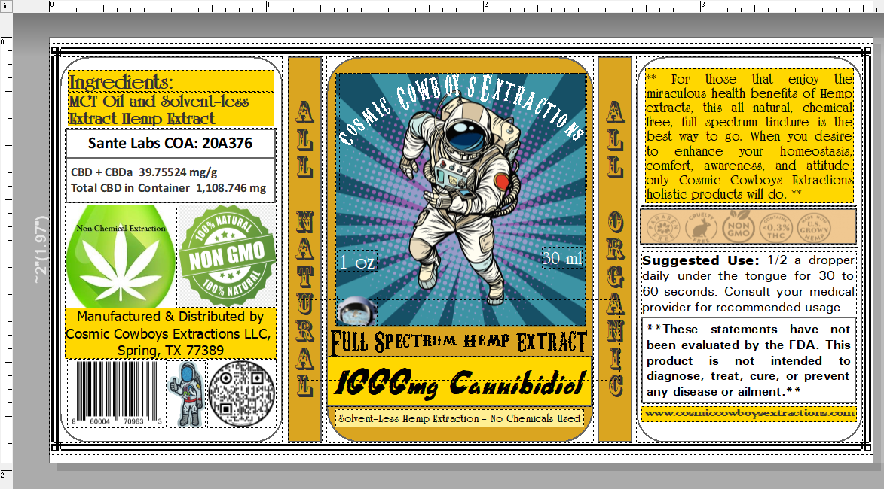

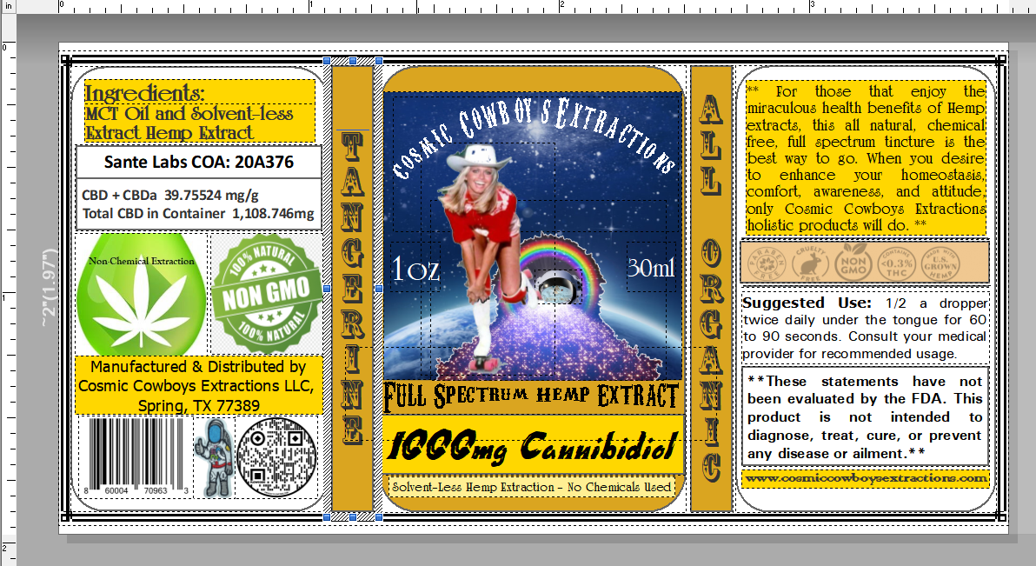

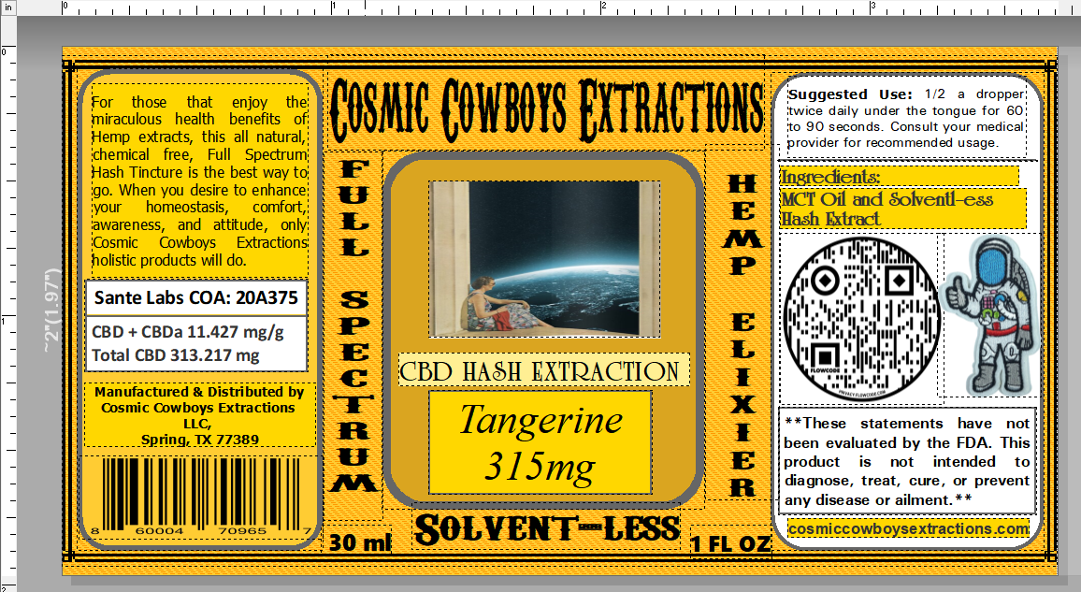

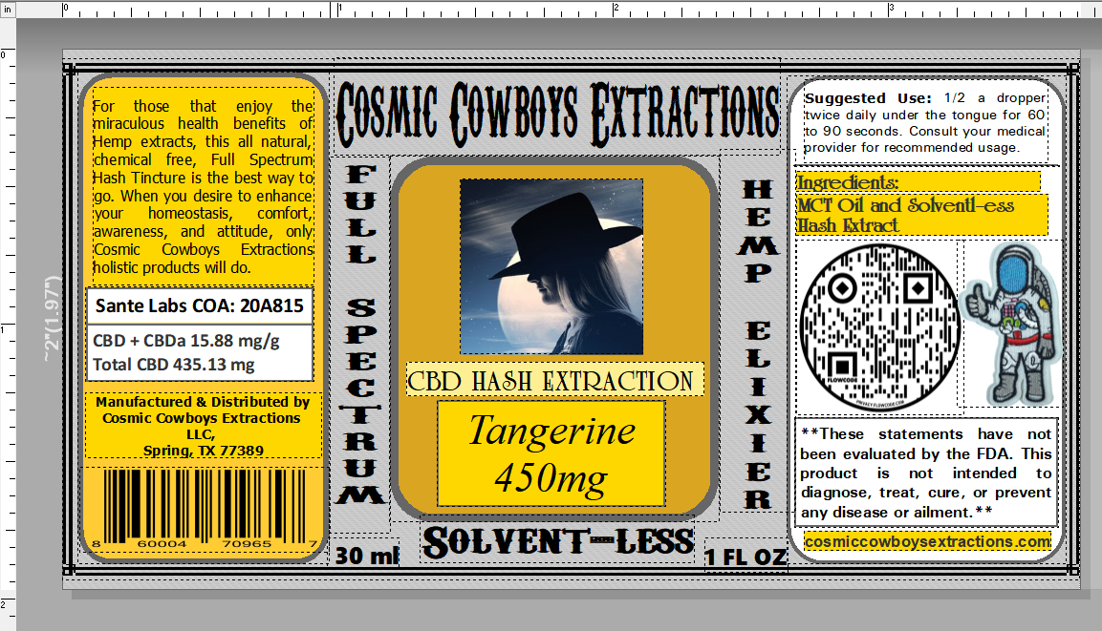

Massage Lotion / Pasithea’s Passion / – we do not have a label for this but we need a generic label for massage schools and parlors, and a retail label as well. They would be 1.25”t x 8”w

Gummy / Gummy Gems / & Hard Candy / Cosmic Comets / Resealable Packages – 1.97”w x 3”t

We are thinking about going to 3”x3” or 4”x4” clear plastic round bottles with screw tops, what do you think?

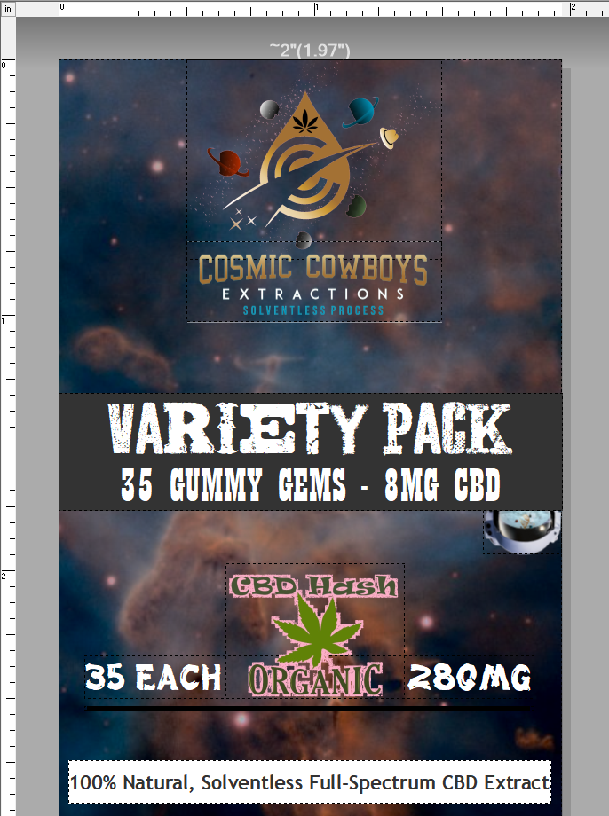

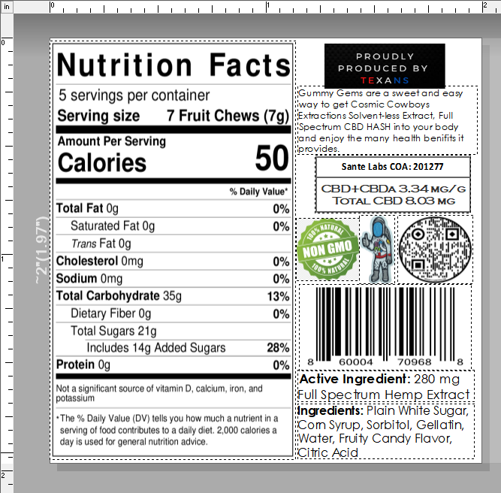

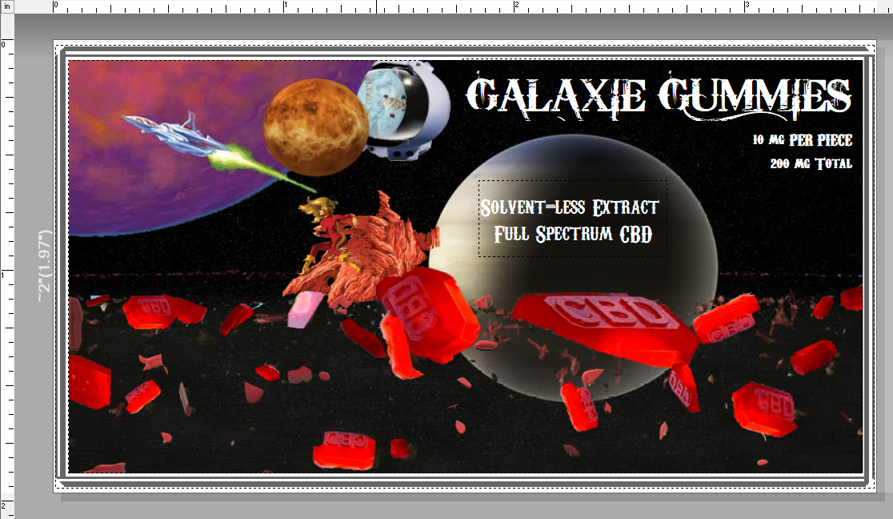

**Priority 2**

Lip Balm / Orbital Lip Balm / 1.97”t x 1.97”w – perforated line for cap removal 3/16” from top

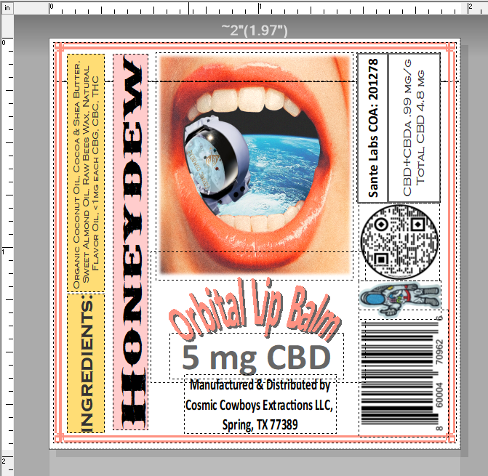

Sweet Tea – 3.15”t x 1.97”w Nutritional label is the same size and these go on square 10 oz bottles

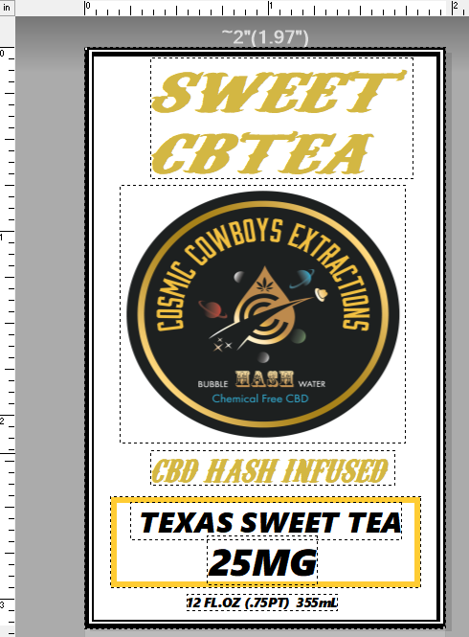

Free samples – 1.97”t x 2.0”w

We only give away dry candies in resealable bags

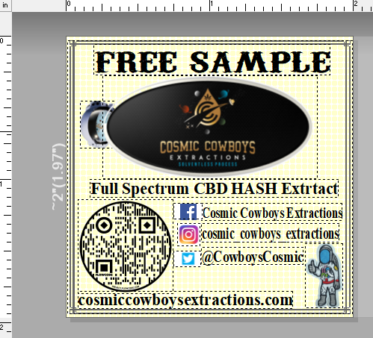

Peanut Butter Cups – we do not have a label currently but it would be 2.5”t x 5.75”w

Krispy Mellow Treats – we do not have a label for our rice krispy treats but they would be 2”t x 3”w

**Priority 3**

K-Cup Coffee – 1”t x 5”w

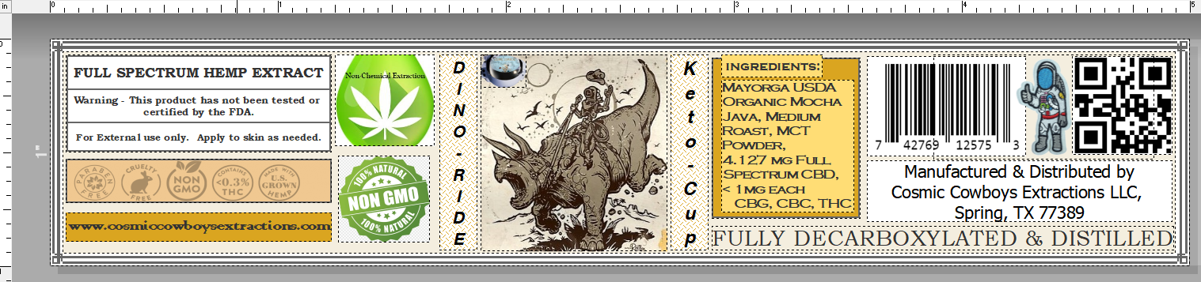

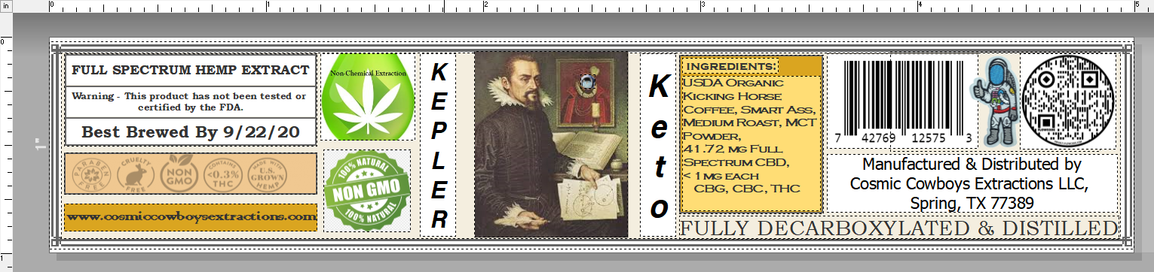

Dry Pet Treats – 2”w x 2”t

